NGO Gallery – Photo Titles
20 photos · short English titles for the gallery page
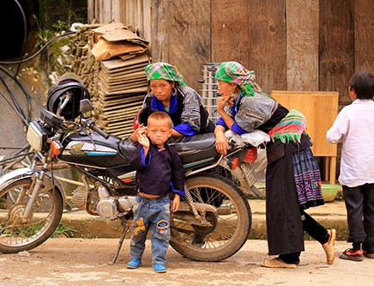  01 Growing Up in the Highlands  1412061364-tre-vung-cao--15-.jpg | 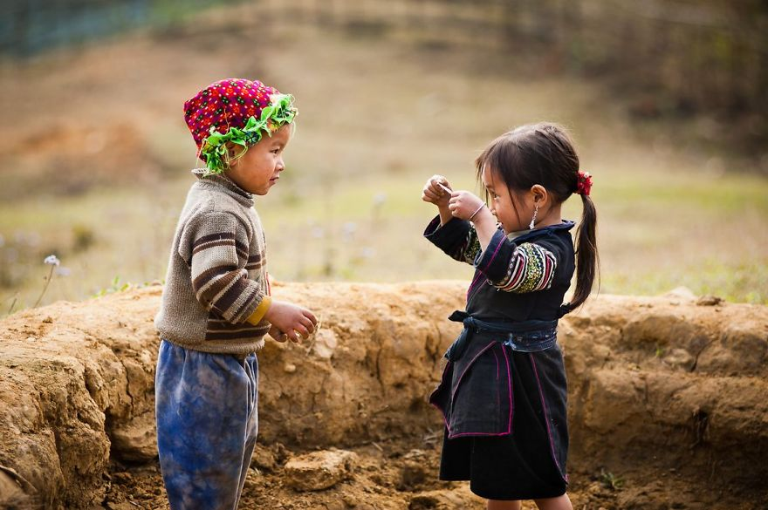  02 Sharing Small Joys  1.jpg
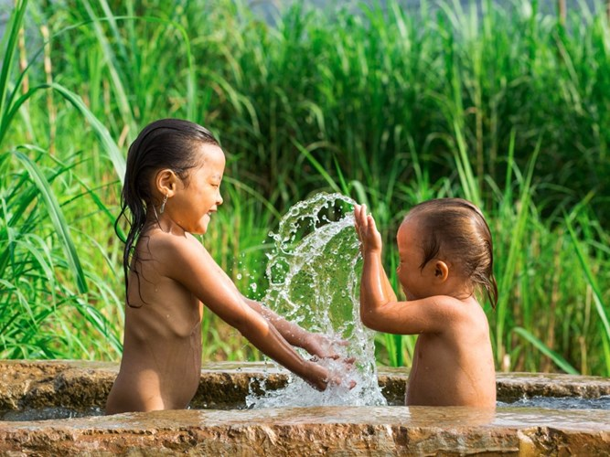  03 A Splash of Joy  1_ZLPR.jpg | 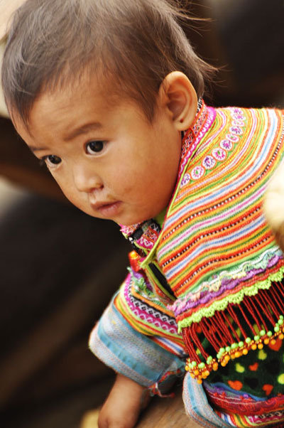  04 Curious Eyes, Bright Future  3.jpg
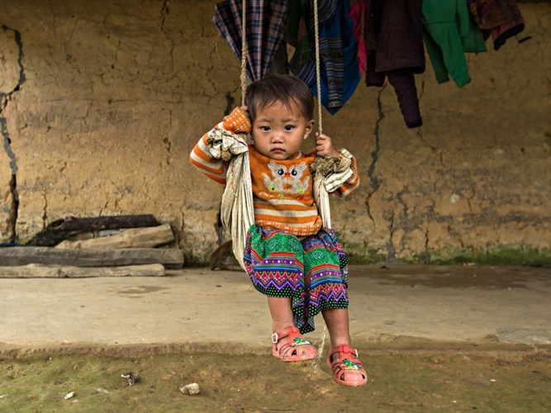  05 Swinging Toward Hope  3_CMVE.jpg | 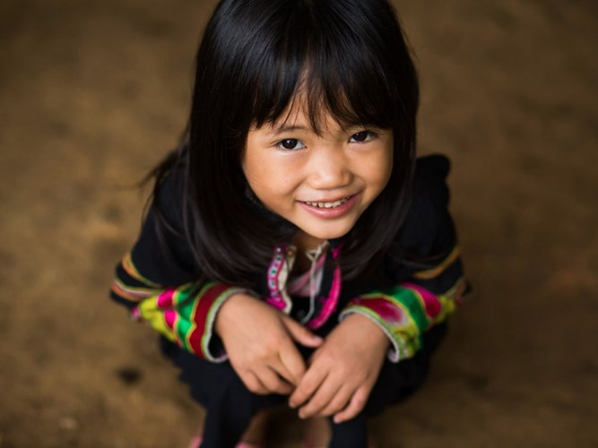  06 A Smile Worth Protecting  8_VVJQ.jpg
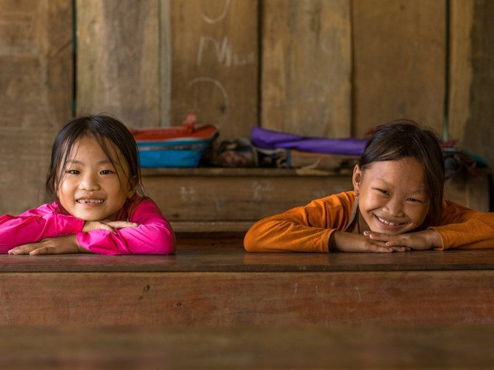  07 Eager to Learn  16_FDJB.jpg | 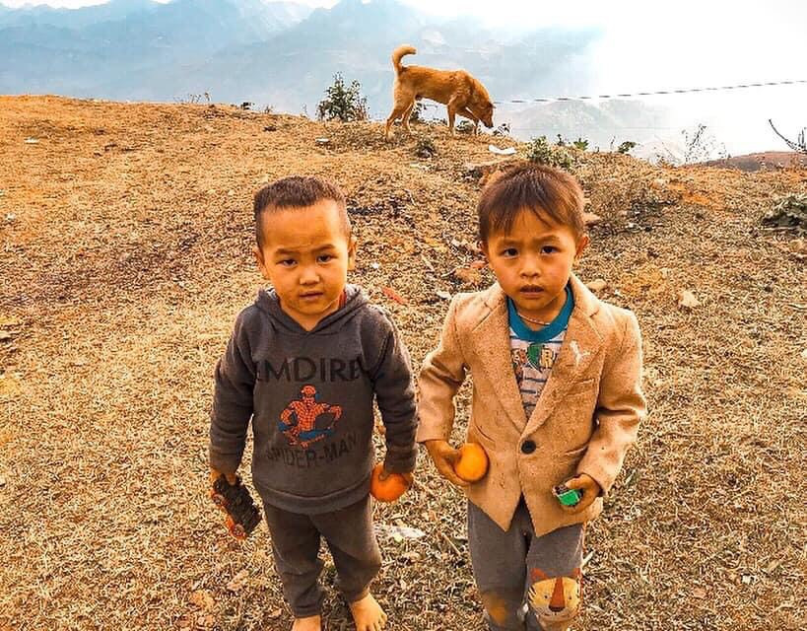  08 Warm Hearts, Cold Hills  20fbaeb5ce5cd25c32fef994dad7417b.jpg
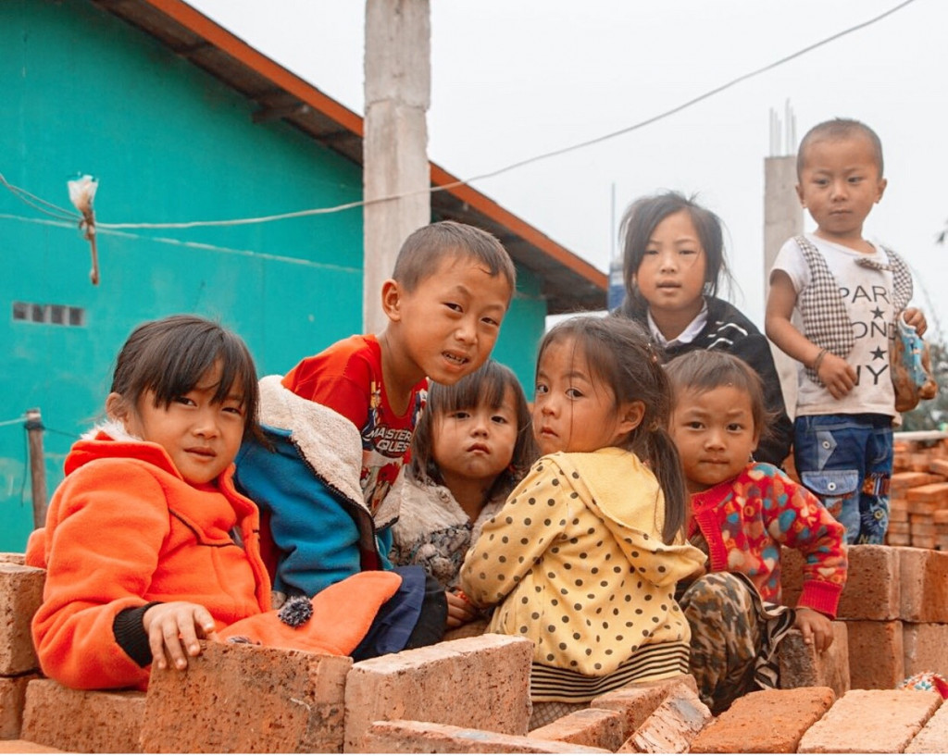  09 Building Their Future  30d7d20e73ceba2b15d9801984fd3d8f.jpg | 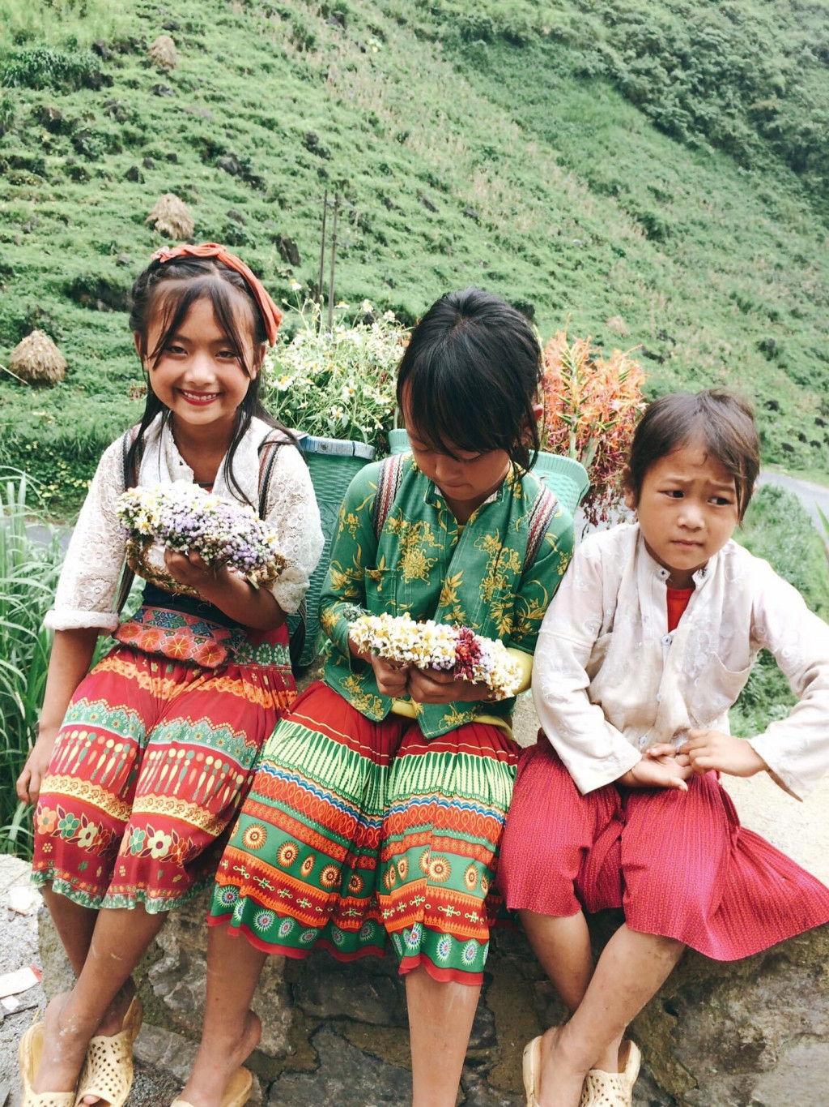  10 Hope in Their Hands  696f45086f2169c2204b9a477fd10d5c.jpg
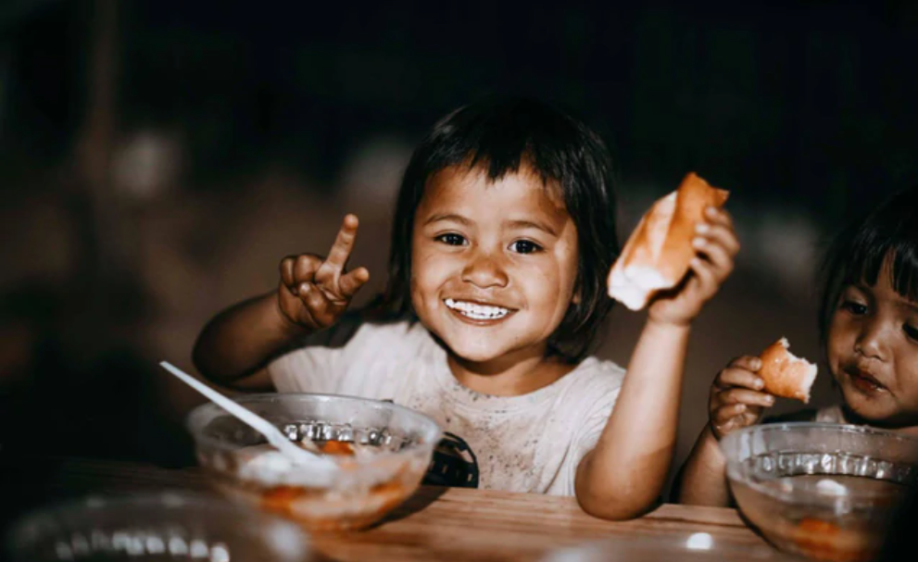  11 A Meal Means the World  866f8c1e-1e59-4daf-9b5d-213adf96d3a1.png | 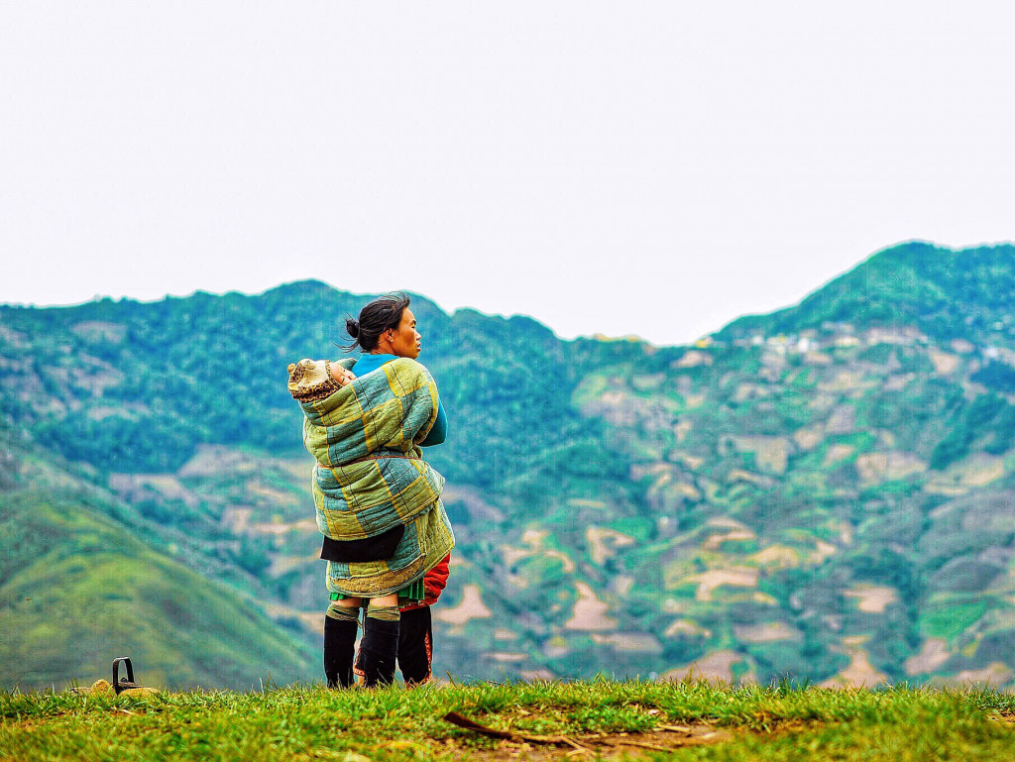  12 Carrying Hope Uphill  32240e618328a16f05c06478c6e2a68d.jpg
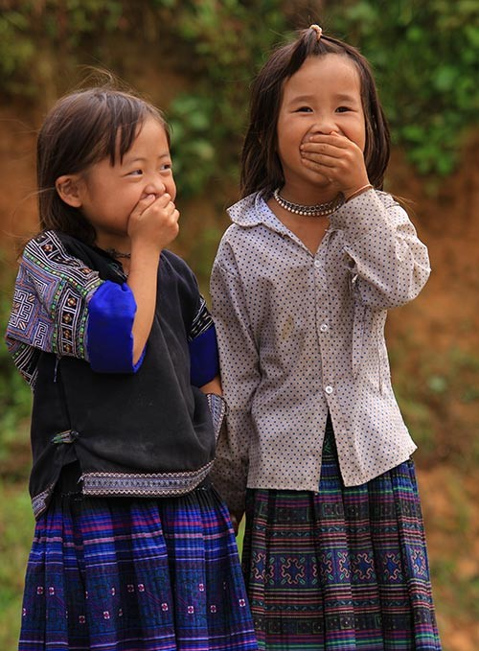  13 Secret Giggles  1412061364-tre-vung-cao--2-.jpg | 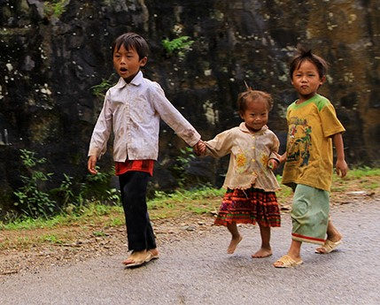  14 Hand in Hand  1412061364-tre-vung-cao--4-.jpg
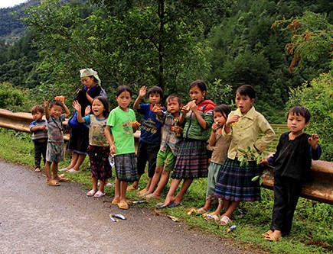  15 Hello from the Mountains  1412061364-tre-vung-cao--6-.jpg | 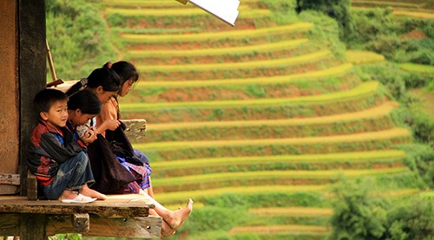  16 Dreaming Above the Terraces  1412061364-tre-vung-cao--7-.jpg
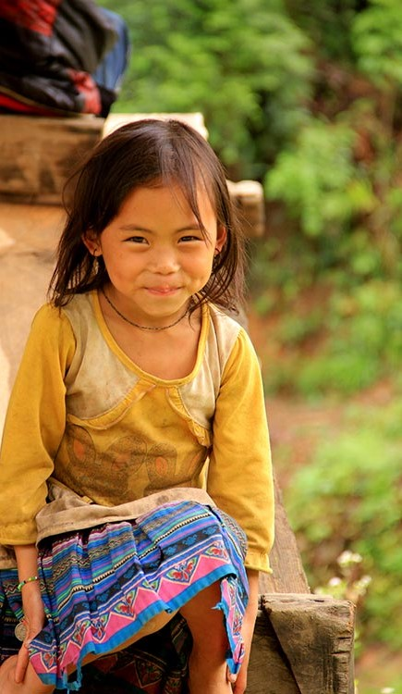  17 Shy Smile, Big Dreams  1412061364-tre-vung-cao--9-.jpg | 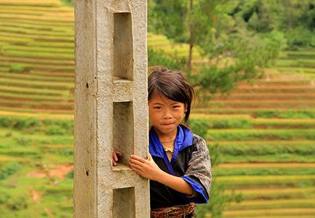  18 Peeking at Tomorrow  1412061364-tre-vung-cao--12-.jpg
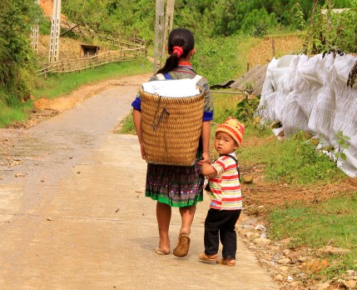  19 Never Letting Go  1412061364-tre-vung-cao--13-.jpg | 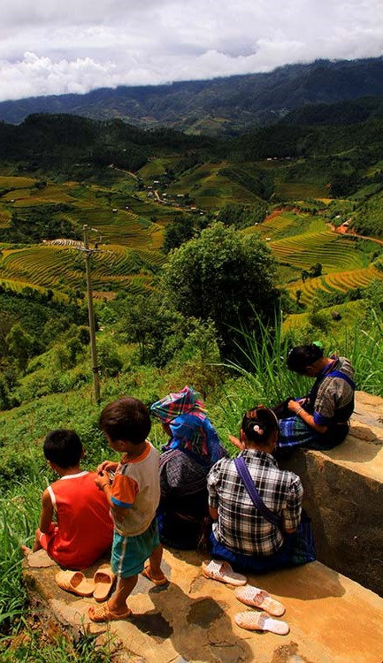  20 Looking Toward Tomorrow  1412061364-tre-vung-cao--14-.jpg

